D E C I S I O N
on the approval of the Regulation on the treatment of
Credit Valuation Adjustment risk for banks

No 119 of 21 May 2026
(in force as of 1 January 2027, with some exceptions - see paragraph 3)

Official Gazette of the Republic of Moldova No 221 Article 391 of 26 May 2026

* * *
EU
Pursuant to Article 60 paragraph (4) and Article 73 paragraph (1) of Law No 202/2017 on the activity of banks (Official Gazette of the Republic of Moldova, 2017, No 434-439, Article 727), the Executive Board of the National Bank of Moldova
DECIDES:
1. The Regulation on the treatment of credit valuation adjustment risk for banks is approved (attached).
2. The Decision of the Executive Board of the National Bank of Moldova No 103/2020 on the approval of the Regulation on the treatment of credit valuation adjustment risk for banks (Official Gazette of the Republic of Moldova, 2020, No 118-123, Article 465), registered with the Ministry of Justice of the Republic of Moldova under No 1564 of 8 May 2020, is repealed.
3. This Decision shall enter into force on 1 January 2027, with the exception of paragraphs 44, 80 and 81, which shall enter into force on the date of entry into force of the Treaty of Accession of the Republic of Moldova to the European Union.
CHAIRMAN
OF THE EXECUTIVE BOARD | Anca-Dana DRAGU
No 119. Chişinău, 21 May 2026.
Annex
to the Decision of the Executive Board
of the National Bank of Moldova
No 119 of 21 May 2026

REGULATION
on the treatment of
Credit Valuation Adjustment risk for banks

This Regulation:
- partially transposes (transposes Articles 381, 382 (1)-(3), (4a)- (4b), 382a, 383, 383a, 383b, 383c, 383d, 383e, 383f, 383g, 383h, 383i, 383j, 383k, 383l, 383m, 383n, 383o, 383p, 383q, 383r, 383s, 383t, 383u, 383v, 383w, 383x, 383z, 384, 385, 386 and partially transposes Article 382(4)) Regulation (EU) No 575/2013 of the European Parliament and of the Council of 26 June 2013 on prudential requirements for credit institutions and investment firms and amending Regulation (EU) No 648/2012, CELEX: 32013R0575, published in the Official Journal of the European Union 176 of 27 June 2013, as last amended by Commission Delegated Regulation (EU) 2025/1496 of 12 June 2025;
- transposes Articles 2, paragraphs 8 and 9 (“financial counterparty” and “non-financial counterparty”) of Regulation (EU) No 648/2012 of the European Parliament and of the Council of 4 July 2012 on OTC derivatives, central counterparties and trade repositories, CELEX: 32012R0648, published in the Official Journal of the European Union 201 of 27 July 2012, as last amended by Directive (EU) 2025/1 of the European Parliament and of the Council of 27 November 2024.

CHAPTER I
GENERAL PROVISIONS
1. The Regulation on the treatment of credit valuation adjustment risk for banks (hereinafter – Regulation) lays down the methodology for determining own funds requirements to cover credit valuation adjustment risk (hereinafter – CVA risk) and the conditions that banks have to comply with in order to use that methodology.
2. The Regulation applies to banks that are legal entities of the Republic of Moldova, including their branches abroad, as well as to branches of banks of other states, with regard to their activity in the Republic of Moldova, hereinafter referred to as banks.
3. For the purposes of calculating the own funds requirements for CVA risk, the following definitions shall apply:
3.1. Credit Valuation Adjustment (CVA) - an adjustment to the average market rate of the portfolio of transactions entered into with a counterparty. This adjustment reflects the current market value of the credit risk that the counterparty represents for the bank, but does not reflect the current market value of the credit risk that the bank represents for the counterparty.
3.2. risk class - any of the following categories: interest rate risk; the credit spread risk of the counterparty; reference spread risk; equity risk; commodity risk; foreign exchange risk;
3.3. financial counterparty - an investment company; a bank; an insurance undertaking or a reinsurance undertaking; an undertaking for collective investment in transferable securities (hereinafter UCITS) and, where applicable, its management company, unless the UCITS is established solely for the purpose of serving one or more employee share purchase plans; an institution for occupational retirement provision (IORP); both an alternative investment fund (AIF) which is either established in the EU Member States or in the Republic of Moldova or is managed by an alternative investment fund manager (AIFM), unless the AIF is established solely for the purpose of serving one or more employee share purchase plans or the AIF is a securitisation special purpose entity, and, where applicable, the AIFM established in the EU Member States or in the Republic of Moldova of that fund; The single central securities depository.
3.4. non-financial counterparty - an entity established in the EU Member States or in the Republic of Moldova, other than the entities referred to in the definition of financial counterparty and representing an entity which is not a financial sector entity but which can participate in financial transactions, in particular derivatives;
3.5. aggregate CVA - the sum of CVAs calculated using the regulatory CVA model for the counterparties referred to in paragraph 17;
3.6. regulatory CVA - the adjustment of the value of a financial instrument designed to reflect counterparty credit risk, calculated in accordance with the capital requirements set by the National Bank of Moldova, including, but not limited to, credit risk regulations for OTC transactions and derivatives;
3.7. CVA portfolio - the portfolio composed of the aggregate CVA and the eligible hedges referred to in subparagraph 17.4.;
3.8. CVA risk - the risk of losses resulting from changes in the value of the CVA, calculated for the portfolio of transactions with a counterparty as defined in the definition of “credit valuation adjustment” or “CVA” due to changes in the credit spread risk factors of a counterparty and changes in other risk factors incorporated into the portfolio of transactions.

CHAPTER II
SCOPE
4. The Bank shall calculate the own funds requirements for CVA risk for all OTC derivatives in respect of all its activities other than credit derivatives recognised in order to reduce risk-weighted exposure amounts for credit risk.
5. The bank shall include in the calculation of own funds set out in paragraph 4 securities financing operations that are measured at fair value in accordance with the accounting framework applicable to the bank where the bank’s CVA risk exposures arising from those operations are material.
6. Transactions with a qualified central counterparty (hereinafter QCCP) and transactions between a client and a clearing member where the clearing member acts as an intermediary between the client and a QCCP and the transactions give rise to a trade exposure of the clearing member to the QCCP shall be excluded from the application of own funds requirements for CVA risk.
7. The following transactions are excluded from the application of the own funds requirements for CVA risk:
7.1. transactions with non-financial counterparties established in the EU Member States, in the Republic of Moldova or with non-financial counterparties established in a third country;
7.1.1. intragroup transactions with non-financial counterparties where all of the following conditions are met:

7.1.1.1. the bank and non-financial counterparties are fully included in the same consolidation and are subject to supervision on a consolidated basis in accordance with the regulations governing the supervision of banks on a consolidated basis;
7.1.1.2. are subject to appropriate centralised risk assessment, measurement and control procedures;
7.2. intragroup transactions concluded with financial counterparties, financial institutions or firms providing ancillary services which are established in the EU Member States or in the Republic of Moldova or which are established in a third country applying the prudential and supervisory requirements of those financial counterparties, banks or firms providing ancillary services which are at least equivalent to those applied in the EU Member States or in the Republic of Moldova, unless Member States adopt national provisions providing for the structural separation of activities within a banking group, in which case the competent authorities may require that intragroup transactions between structurally separated entities be included in the own funds requirements;
7.3. transactions with counterparties for which the provisions of the Regulation on the treatment of banks’ credit risk using standardised approach, approved by the Decision of the Executive Board of the National Bank of Moldova No 111/2018, specify a 0% risk weight for exposures to those counterparties.
8. With regard to subparagraph7.1, if the bank is no longer exempted by exceeding the exemption threshold or due to a change in the exemption threshold, unfulfilled contracts remain exempted until maturity.
9. By way of derogation from paragraph 7, the bank may choose to calculate the own funds requirements for CVA risk, using any of the approaches referred to in paragraph 11, for transactions that are excluded under paragraph 7, if the bank uses eligible hedges determined in accordance with paragraphs 119 to 124 to mitigate the CVA risk of those transactions. Banks shall establish policies to specify the application and calculation of the own funds requirements for CVA risk for such transactions.
10. If banks choose to calculate the own funds requirements for CVA risk in respect of the transactions referred to in paragraph 7, they shall report to the National Bank of Moldova the results of the calculations of the own funds requirements for CVA risk for all transactions referred to in paragraph 7. For the purposes of that reporting requirement, banks shall calculate the own funds requirements for CVA risk using the relevant approaches set out in paragraph 11 that they would have used to meet an own funds requirement for CVA risk, had those transactions not been excluded from the scope under paragraph 7.

CHAPTER III
APPROACHES OF THE CALCULATION OF
OWN FUNDS RISK REQUIREMENTS FOR CVA
11. The Bank shall calculate the own funds requirements for CVA risk for all transactions referred to in paragraphs 4-10 in accordance with the following approaches:
11.1. the standardised approach set out in paragraphs 17-20, if the bank has received the prior approval of the National Bank of Moldova to use that approach;
11.2. the basic approach set out in paragraphs 113–115;
11.3. the simplified approach set out in paragraphs 116–118, provided that the bank meets the conditions set out in paragraph 116.
12. The Bank shall not use the approach referred to in subparagraph 11.3. in combination with the approach referred to in subparagraphs 11.1 or 11.2.
13. The Bank may use on an ongoing basis a combination of the approaches referred to in subparagraphs 11.1. and 11.2. to calculate the own funds requirements for CVA risk for:
13.1. different counterparts;
13.2. different eligible netting sets with the same counterparty;
13.3. different transactions in the same eligible netting set, subject to the satisfaction of any of the conditions referred to in paragraph 15.
14. For the purposes of subparagraph 13.3, banks shall divide the eligible netting set into a hypothetical netting set containing the transactions subject to the approach referred to in subparagraph 11.1 and a hypothetical netting set containing the transactions subject to the approach referred to in subparagraph 11.2.
15. For the purposes of subparagraph 13.3, the conditions referred to in that subparagraph include the following:
15.1. the split is consistent with the treatment of the legal netting set when calculating the CVA for accounting purposes;
15.2. the approval granted by the National Bank of Moldova to use the approach referred to in subparagraph 11.1 shall be limited to the corresponding hypothetical netting set and shall not cover all transactions in the eligible netting set.
16. Banks shall document how they use on an ongoing basis a combination of the approaches referred to in subparagraphs 11.1 and 11.2, as set out in paragraph 15, to calculate the own funds requirements for CVA risk.

CHAPTER IV
STANDARDISED APPROACH

Section 1
General provisions
17. The National Bank of Moldova shall grant a bank prior approval to calculate its own funds requirements for CVA risk for a portfolio of transactions with one or more counterparties in accordance with paragraph 20, using the standardised approach, after having assessed whether the bank complies with the following requirements:
17.1. the bank has established a subdivision which is responsible for the overall risk management of the bank and for hedging the CVA risk;
17.2. for each counterparty concerned, the bank has developed a regulatory CVA model to calculate the CVA of that counterparty in accordance with paragraphs 21 to 27;
17.3. the bank is able to calculate, at least monthly, the CVA sensitivities of each counterparty concerned to the relevant risk factors determined in accordance with paragraphs 28-40;
17.4. for all positions in eligible hedges recognised in accordance with paragraphs 119–124 for the purposes of calculating the own funds requirements for CVA risk using the standardised approach, the bank shall be able to calculate, at least monthly, the sensitivities of those positions to the relevant risk factors determined in accordance with paragraphs 28–40;
17.5. the bank has established a risk control sub-division that is independent of the trading sub-divisions and the unit referred to in subparagraph 17.1 and that reports directly to the management body; the risk control sub-division is responsible for the design and implementation of the standardised approach and prepares and analyses monthly reports on the results of that approach and, in addition, the risk control sub-division assesses the adequacy of the bank’s trading limits and includes the results of that assessment in its monthly reports; the risk control sub-division shall have sufficient staff with the appropriate level of competence to fulfil its purpose.
18. For the purposes of subparagraph 17.3, the sensitivity of a counterparty’s CVA to a risk factor means the relative change in the value of that CVA, following a change in the value of one of the relevant risk factors of that CVA, calculated using the bank’s regulatory CVA model in accordance with paragraphs 63 to 69.
19. For the purposes of subparagraph 17.4, the sensitivity of a position in an eligible hedge to a risk factor means the relative change in the value of that position as a result of a change in the value of one of the relevant risk factors of that position, calculated using the valuation model of the bank in accordance with paragraphs 63 to 69.
20. Banks shall determine the own funds requirements for CVA risk under the standardised approach as the sum of the following own funds requirements calculated in accordance with paragraphs 28-40:
20.1. the own funds requirements for delta risk reflecting the risk of changes in the bank's CVA portfolio due to changes in relevant non-volatility related risk factors;
20.2. the own funds requirements for vega risk reflecting the risk of changes in the bank's CVA portfolio due to changes in relevant volatility-related risk factors.

Section 2
Regulatory CVA model
21. A regulatory CVA model used to calculate the own funds requirements for CVA risk in accordance with paragraphs 17-20 shall be conceptually sound and implemented with integrity and shall comply with all of the following requirements:
21.1. the regulatory CVA model is capable of modelling the CVA of a given counterparty, recognising netting and margin agreements at netting set level, where applicable;
21.2. the bank shall estimate the default probabilities of the counterparty on the basis of the credit spreads of the counterparty and the loss given default according to the expected market consensus for that counterparty;
21.3. the expected loss given default referred to in subparagraph 21.1 is the same as the loss given default according to the expected market consensus referred to in subparagraph 21.2, unless the bank can demonstrate that the ranking of the portfolio of transactions with that counterparty differs from the ranking of senior unsecured bonds issued by that counterparty;
21.4. at each subsequent paragraph in time, the simulated discounted future exposure of the portfolio of transactions with a counterparty shall be calculated using an exposure model by re-evaluating all transactions in that portfolio on the basis of simulated common changes in market risk factors that are material to those transactions, using an appropriate number of scenarios and updating prices up to the date of the calculation on the basis of risk-free interest rates;
21.5. the regulatory CVA model is capable of modelling the material dependence between the simulated discounted future exposure of the portfolio of transactions and the credit spreads of the counterparty;
21.6. where transactions in the portfolio are included in a netting set subject to a margin agreement and daily market valuation, collateral posted and received as part of that agreement shall be recognised as a risk-mitigating factor in the simulated discounted future exposure provided that the following conditions are met:
21.6.1. the bank shall determine the margin period of risk for that netting set in accordance with the requirements for applying the internal model method to counterparty credit risk and shall reflect that margin period in the calculation of the simulated discounted future exposure;
21.6.2. all applicable features of the margin agreement, including the frequency of margin calls, the type of contractually eligible collateral, the threshold amounts, the minimum amounts of transfers, the independent amounts and the initial margins for both the bank and the counterparty are appropriately reflected in the calculation of the simulated discounted future exposure.
21.6.3. the bank has established a collateral management unit that complies with the application of the internal model method to the credit risk of the counterparty to all collateral recognised for the purpose of calculating the own funds requirements for CVA risk using the standardised approach.
22. For the purposes of subparagraph 21.1, the CVA shall have a positive sign and shall be calculated on the basis of the expected default losses of the counterparty, an appropriate set of probability of default of the counterparty at future times and an appropriate set of simulated discounted future exposures of the portfolio of transactions with that counterparty at future times until the maturity of the longest transaction in that portfolio.
23. For the purposes of the demonstration referred to in subparagraph 21.3, collateral received from the counterparty shall not change the ranking of the exposure.
24. For the purposes of subparagraph 21.6.3, where a bank has already established a collateral management unit to use the internal model method applied to counterparty credit risk, it shall not be required to establish an additional collateral management subdivision if that bank demonstrates to its competent authority that that subdivision complies with the requirements set out in applying the internal model method to counterparty credit risk for collateral recognised for the purpose of calculating own funds requirements for CVA risk using the standardised approach.
25. For the purposes of subparagraph 21.2, if the spreads of the counterparty credit default swaps are observable in the market, the bank shall use those spreads. Where such credit default swap spreads are not available, banks shall use one of the following:
25.1. credit spreads on other instruments issued by the counterparty that reflect current market conditions;
25.2. the approximate margins that are appropriate in view of the rating, industry and counterparty region.
26. The bank using a regulatory CVA model shall comply with all qualitative requirements as follows:
26.1. the exposure model referred to in paragraph 21 is part of the bank's internal CVA risk management system which includes the identification, measurement, management, approval and internal reporting of CVA and CVA risk for accounting purposes;
26.2. the bank has a process in place to ensure compliance with a documented set of internal policies, controls, model performance reviews and procedures relating to the exposure model referred to in paragraph 21;
26.3. the bank has an independent validation unit that is responsible for the initial and ongoing effective validation of the exposure model referred to in paragraph 21; this unit is independent of the loan and trading units, including the unit referred to in subparagraph 17.1, and reports directly to the executive body; the unit has sufficient staff with an appropriate level of competence to fulfil that purpose;
26.4. the executive body actively participates in the risk control process and considers CVA risk control to be an essential aspect of economic activity, to which adequate resources must be allocated;
26.5. the bank documents the process of initial and ongoing validation of the exposure model referred to in paragraph 21, to a level of detail that would allow a third party to understand how their models, limitations and key assumptions function and to recreate the analysis; that documentation sets out the minimum frequency with which ongoing validation is carried out, as well as other circumstances, such as a sudden change in market behaviour, in which additional validation is carried out; the documentation describes how validation is performed in terms of data flows and portfolios, what analyses are used and how representative counterparty portfolios are constituted;
26.6. the valuation models used in the exposure model referred to in paragraph 21 for a given scenario of simulated market risk factors shall be tested against independent benchmarks appropriate for a wide range of market conditions as part of the initial and ongoing model validation process; the options pricing models take into account the non-linearity of the value of the option in terms of market risk factors;
26.7. as part of the bank's internal audit process, an independent review of its internal CVA risk management system referred to in subparagraph 26.1 shall be carried out on a regular basis; that review includes the activities of both the unit referred to in subparagraph 17.1 and the independent validation unit referred to in subparagraph 26.3;
26.8. the regulatory CVA model used by the bank to calculate the simulated discounted future exposure referred to in paragraph 21 reflects the conditions and specifications of transactions and margin contracts in a timely, complete and prudent manner; the conditions and specifications shall be kept in a secure database, which shall be subject to a formal and regular audit; the transmission of data on transaction conditions and specifications and margin contracts for integration into the exposure model is also subject to internal audit, and formal reconciliation processes exist between the internal model and source data systems to verify on an ongoing basis that transaction specifications and conditions and margin contracts are correctly or at least prudently reflected in the exposure calculation system;
26.9. current and historical market data inputs used in the bank model for the calculation of the simulated discounted future exposure referred to in paragraph 21 shall be obtained independently of the business lines and entered into that model in a timely and complete manner and kept in a secure database subject to formal and regular audit; the bank has a well-developed data integrity verification process in place to manage observations of inadequate data; where the model is based on market data substitution data, the bank shall develop internal policies to identify suitable substitutes and demonstrate empirically and on an ongoing basis that substitutes provide a prudent representation of the underlying risk;
26.10. the exposure model referred to in paragraph 21 shall include the transaction-specific and contractual information that is necessary to be able to aggregate exposures at the level of the netting set; the bank verifies whether the transactions are assigned to the appropriate netting set under the model.
27. For the purposes of calculating the own funds requirements for CVA risk, the exposure model referred to in paragraph 21 may have different specifications and assumptions to meet all the requirements set out in paragraphs 21 to 26, except that its market data inputs and the recognition of offsetting are the same as those used for accounting purposes.

Section 3
Own funds requirements for delta and vega risks
28. Banks shall apply the delta and vega risk factors described in paragraphs 41–62 and the process set out in paragraphs 29–40 to calculate the own funds requirements for delta and vega risks.
29. For each risk class referred to in paragraph 3, the sensitivity of aggregate CVAs and the sensitivity of all positions in eligible hedges that fall under the own funds requirements for delta or vega risk to each of the applicable delta or vega risk factors included in that risk class shall be calculated using the appropriate formulae set out in paragraphs 63 to 69. Where the value of an instrument depends on several risk factors, the sensitivity shall be determined separately for each risk factor.
30. For the calculation of vega risk sensitivities of aggregate CVAs, both the sensitivities to volatilities used in the exposure model to simulate risk factors and the sensitivities to volatilities used to revalue transactions with options in the portfolio of transactions with the counterparty shall be included.
31. By way of derogation from paragraph 28, subject to prior approval by the National Bank of Moldova, the bank may use alternative definitions of delta and vega risk sensitivities when calculating the own funds requirements of a position in the trading book, provided that the bank meets all of the following conditions:
31.1. those alternative definitions are used for internal risk management purposes or for profit and loss reporting to the management body by an independent risk control unit within the bank;
31.2. the bank demonstrates that these alternative definitions are more appropriate to reflect the sensitivities of the position than the formulas set out in paragraphs 63 to 69 and that the resulting delta and vega risk sensitivities do not differ materially from those obtained by applying the formulas set out in paragraphs 63 to 69.
32. Where an eligible hedge is an index instrument, banks shall calculate the sensitivities of that eligible hedge to all relevant risk factors by applying the change in one of the relevant risk factors to each of the components of the index.
33. The bank may introduce additional risk factors corresponding to qualified index instruments for the following risk classes:
33.1. counterparty credit spread risk;
33.2. reference spread risk; and
33.3. equity risk.
34. With regard to delta risks, an index instrument is considered qualified if it meets the conditions set out in the market risk treatment regulations under the standardised approach. As regards vega risks, all index instruments are considered qualified.
35. The bank calculates the sensitivities of CVA and eligible hedges to qualified index risk factors in addition to the sensitivities to non-index risk factors.
36. The bank shall calculate the delta and vega risk sensitivities to a risk factor of an index qualified as unique sensitivity to the underlying qualified index. If 75 % of the components of a qualified index are matched with the same sector as set out in paragraphs 85 to 89, 93 to 98 and 103 to 107, the bank shall match the qualified index with that sector. In other cases, the bank shall match the sensitivity with the relevant qualifying index bucket.
37. The weighted sensitivities of the aggregate CVA and the market value of all eligible hedges for each risk factor shall be calculated by multiplying those net sensitivities by the corresponding risk weight in accordance with the following formulae:

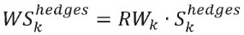
where:
k | = the index that denotes the risk factor k;
 | = the weighted sensitivity of the aggregate CVA to risk factor k;
RW _{k} | = the risk weight applicable to risk factor k;
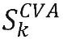 | = the net sensitivity of the aggregate CVA to risk factor k;
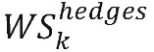 | = the weighted sensitivity of the market value of all eligible hedges in the CVA portfolio to risk factor k;
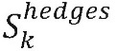 | = the net sensitivity of the market value of all eligible hedges in the CVA portfolio to risk factor k.

38. Banks shall calculate the net-weighted sensitivity WS_{k} of the CVA portfolio to risk factor k in accordance with the following formula:



39. The weighted net sensitivities within the same bucket shall be aggregated in accordance with the following formula, using the corresponding correlations ρ _{kl} for the weighted sensitivities within the same bucket set out in paragraphs 75-77, 90, 91, 99 and 100, giving rise to the bucket-specific sensitivity K_{b}:

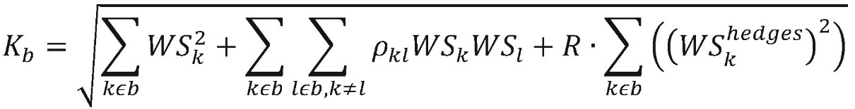
where:
K_{b} | = the bucket-specific sensitivity of bucket b;
WS_{k} | = the net-weighted sensitivities;
ρ_{kl} | = the corresponding intra-bucket correlation parameters;
R | = the hedging disallowance parameter equal to 0,01.

40. The bucket-specific sensitivity shall be calculated in accordance with paragraphs 37 to 39 for each bucket within a risk class. Once the bucket-specific sensitivity has been calculated for all buckets, the weighted sensitivities to all risk factors across buckets shall be aggregated in accordance with the following formula, using the corresponding correlations γ_{bc} for the weighted sensitivities in different buckets set out in paragraphs 75 to 77, 83, 84, 92, 101, 102, 108, 111 and 112 giving rise to the risk-class specific own funds requirements for delta or vega risk:

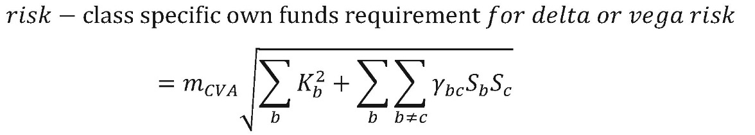
where:
m_{CVA} | = a multiplier factor which is equal to 1; The National Bank of Moldova may increase the value of m _{CVA} if the bank’s regulatory CVA model shows deficiencies preventing the appropriate measurement of the own funds requirements for CVA risk;
K_{b} | = the bucket-specific sensitivity of bucket b;
γ_{bc} | = the correlation parameter between buckets b and c;

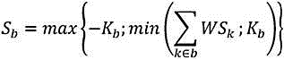 | for all risk factors in bucket b;

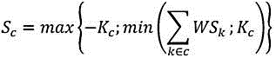 | for all risk factors in bucket c.

Section 4
Interest rate risk factors
41. For the interest rate delta risk factors, including inflation rate risk, there shall be one bucket per currency, with each bucket containing different types of risk factors.
42. The interest rate delta risk factors that are applicable to interest-rate sensitive instruments in the CVA portfolio shall be the risk-free rates per currency concerned and per each of the following maturities: 1 year, 2 years, 5 years, 10 years and 30 years.
43. The interest rate delta risk factors applicable to inflation-rate sensitive instruments in the CVA portfolio shall be the inflation rates per currency concerned and per each of the following maturities: 1 year, 2 years, 5 years, 10 years and 30 years.
44. The currencies for which the bank shall apply the interest rate delta risk factors in accordance with paragraphs 41 to 43 shall be euro, Swedish krona, Australian dollar, Canadian dollar, British pound sterling, Japanese yen and US dollar, the reporting currency of the bank and the currency of a Member State participating in the Exchange Rate Mechanism II (ERM II).
45. For currencies not specified in paragraph 44, the interest rate delta risk factors shall be the absolute change of the inflation rate and the parallel shift of the entire risk-free curve for a given currency.
46. Banks shall obtain risk-free rates per currency from money market instruments held in their trading book that have the lowest credit risk, including overnight index swaps.
47. Where banks cannot apply the approach referred to in paragraph 46, risk-free rates shall be based on one or more market-implicit swap curves used by banks to mark positions to market, such as interbank offered rate swap curves.
48. Where the data on market-implicit swap curves described in paragraph 41 are insufficient, the risk-free rates may be derived from the most appropriate sovereign bond curve for a given currency.
49. The interest rate vega risk factor applicable to instruments in the CVA portfolio sensitive to interest rate volatility shall be all the volatilities of the interest rate of all tenors for a given currency. The inflation rate vega risk factor applicable to instruments in the CVA portfolio sensitive to inflation rate volatility shall be all the volatilities of the inflation rate of all tenors for a given currency. There shall be one net interest rate sensitivity and one net inflation rate sensitivity computed for each currency.
Section 5
Foreign exchange risk factors
50. The foreign exchange delta risk factors to be applied by banks to instruments in the CVA portfolio sensitive to foreign exchange spot rates shall be the spot foreign exchange rates between the currency in which an instrument is denominated and the bank’s reporting currency or the bank’s base currency, where the bank is using a base currency in accordance with the regulatory provisions for the treatment of market risk under the standardised approach. There shall be one bucket per currency pair, containing a single risk factor and a single net sensitivity.
51. The foreign exchange vega risk factors to be applied by banks to instruments in the CVA portfolio sensitive to foreign exchange volatility shall be the implied volatilities of foreign exchange rates between the currency pairs referred to in paragraph 50. There shall be one bucket for all currencies and maturities, containing all foreign exchange vega risk factors and a single net sensitivity.
52. Banks shall not be required to distinguish between onshore (domestic) and offshore (international) variants of a currency for foreign exchange delta and vega risk factors.

Section 6
Counterparty credit spread risk factors
53. The counterparty credit spread delta risk factors applicable to counterparty credit spread sensitive instruments in the CVA portfolio shall be the credit spreads of individual counterparties and reference names and qualified indices for the following maturities: 0,5 years, 1 year, 3 years, 5 years and 10 years.
54. The counterparty credit spread risk class shall not be subject to vega risk own funds requirements.
Section 7
Reference credit spread risk factors
55. The reference credit spread delta risk factors applicable to reference credit spread sensitive instruments in the CVA portfolio shall be the credit spreads of all maturities for all reference names within a bucket. There shall be one net sensitivity computed for each bucket.
56. The reference credit spread vega risk factors applicable to instruments in the CVA portfolio sensitive to reference credit spread volatility shall be the the volatilities of the credit spreads of all tenors for all reference names within a bucket. There shall be one net sensitivity computed for each bucket.
Section 8
Equity risk factors
57. The buckets for all equity risk factors shall be the buckets referred to in paragraphs 99 and 100.
58. The equity delta risk factors to be applied by banks to instruments in the CVA portfolio sensitive to equity spot prices shall be the spot prices of all equities mapped to the same bucket referred to in paragraph 57. There shall be one net sensitivity computed for each bucket.
59. The equity vega risk factors to be applied by banks to instruments in the CVA portfolio sensitive to equity volatility shall be the implied volatilities of all equities mapped to the same bucket referred to in paragraph 57. There shall be one net sensitivity computed for each bucket.
Section 9
Commodity risk factors
60. The buckets for all commodity risk factors shall be the sector buckets referred to in paragraphs 109 and 110.
61. The commodity delta risk factors to be applied by banks to instruments in the CVA portfolio sensitive to commodity spot prices shall be the spot prices of all commodities mapped to the same sector bucket referred to in paragraph 60. There shall be one net sensitivity computed for each sector bucket.
62. The commodity vega risk factors to be applied by banks to instruments in the CVA portfolio sensitive to commodity price volatility shall be the implied volatilities of all commodities mapped to the same sector bucket referred to in paragraph 60. There shall be one net sensitivity computed for each sector bucket.
Section 10
Delta and vega risk sensitivities
63. Banks shall calculate the delta sensitivities consisting of interest rate risk factors as follows:
63.1. the delta sensitivities of the aggregate CVA to risk factors consisting of risk-free rates as well as of an eligible hedge to those risk factors shall be calculated as follows:

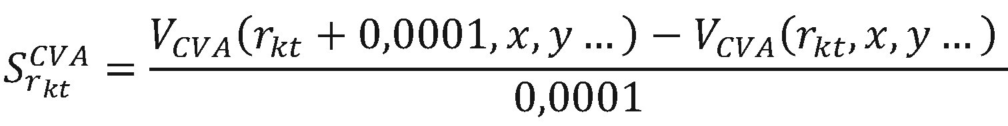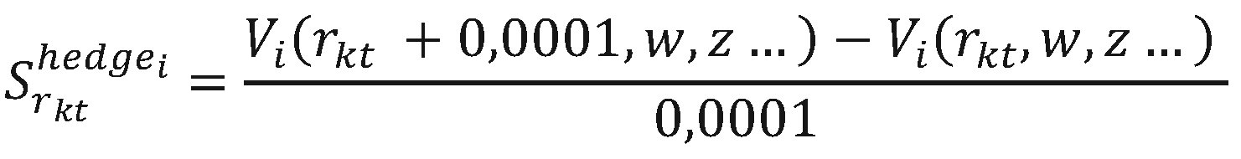

where:
= the sensitivities of the aggregate CVA to a risk-free rate risk factor;
r_{kt} = the value of the risk-free rate factor k with maturity t;
V_{CVA} = the aggregate CVA calculated by the regulatory CVA model;
x, y = risk factors other than r_{kt} in V_{CVA};
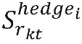= the sensitivities of the eligible hedge i to a risk-free rate risk factor;
V_{i} = the pricing function of the eligible hedge i;
w, z = risk factors other than r_{kt} in the pricing function V_{i}.
63.2. the delta sensitivities to risk factors consisting of inflation rates as well as of an eligible hedge to those risk factors, shall be calculated as follows:

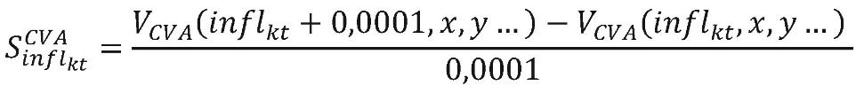

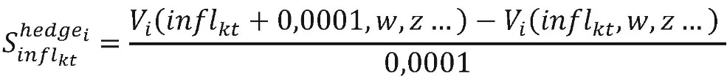
where:
= the sensitivities of the aggregate CVA to an inflation rate risk factor;
infl_{kt} = the value of an inflation rate risk factor k with maturity t;
V_{CVA} = the aggregate CVA calculated by the regulatory CVA model;
x, y = risk factors other than infl_{kt} in V_{CVA};
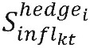= the sensitivities of the eligible hedge i to an inflation rate risk factor;
V _{i} = the function for assessing eligible coverage i;
w, z = risk factors other than infl_{kt} in the pricing function V_{i}.

64. Banks shall calculate the delta sensitivities of the aggregate CVA to risk factors consisting of foreign exchange spot rates as well as of an eligible hedge instrument to those risk factors, as follows:

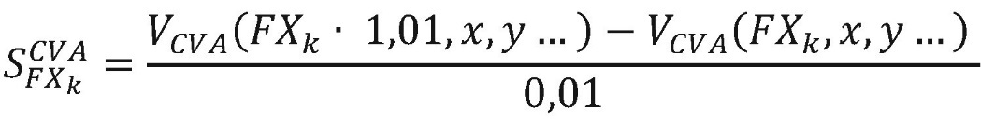

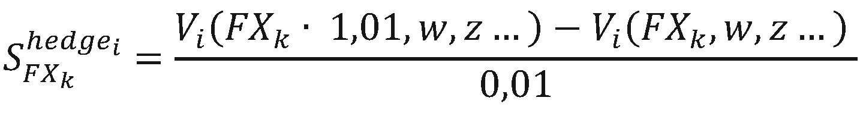
where:
= the sensitivities of the aggregate CVA to a foreign exchange spot rate risk factor;
FX_{k} = the value of the foreign exchange spot rate risk factor k;
V_{CVA} = Aggregated CVA calculated on the basis of the regulatory CVA model;
x, y = risk factors other than FX _{k} in V_{CVA};
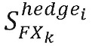= the sensitivities of the eligible hedge i to a foreign exchange spot rate risk factor;
V_{i} = the pricing function of the eligible hedge i;
w, z = risk factors other than FX _{k} in the pricing function V_{i}.

65. Banks shall calculate the delta sensitivities of the aggregate CVA to risk factors consisting of the counterparty credit spread rates, as well as of an eligible hedge instrument to those risk factors, as follows:

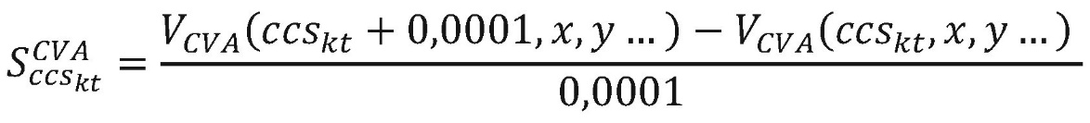

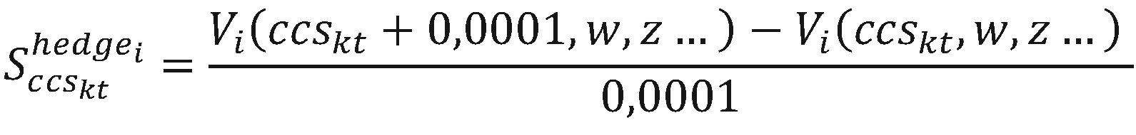
where:
= the sensitivities of the aggregate CVA to a counterparty credit spread rate risk factor;
ccs_{kt =} the value of the counterparty credit spread rate risk factor k at maturity t;
V_{CVA} = the aggregate CVA calculated by the regulatory CVA model;
x, y = risk factors other than ccs_{kt} in V_{CVA};
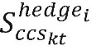= the sensitivities of the eligible hedge i to a counterparty credit spread rate risk factor;
V _{i} = the pricing function of the eligible hedge i;
w, z = risk factors other than ccs_{kt} in the pricing function V_{i} .

66. Banks shall calculate the delta sensitivities of the aggregate CVA to risk factors consisting of reference credit spread rates as well as of an eligible hedge instrument to those risk factors, as follows:

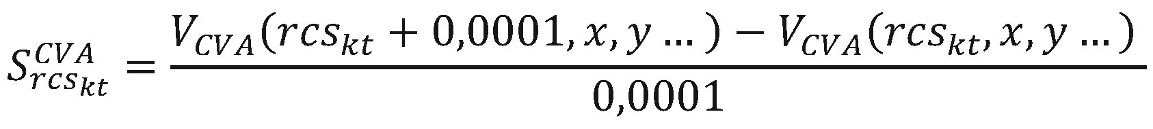

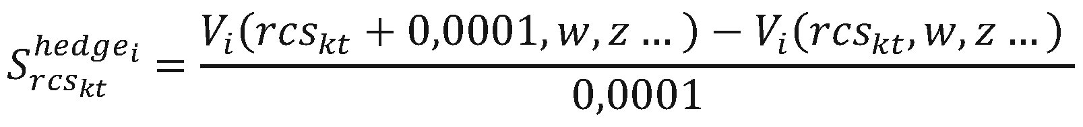
where:
= the sensitivities of the aggregate CVA to a reference credit spread rate risk factor;
rcs_{kt} = the value of the reference credit spread rate risk factor k at maturity t;
V_{CVA} = the aggregate CVA calculated by the regulatory CVA model;
x, y = risk factors other than ccs_{kt} in V_{CVA};
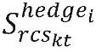= the sensitivities of the eligible hedge i to a reference credit spread rate risk factor;
V_{i} = the pricing function of the eligible hedge i;
w, z = risk factors other than ccs _{kt} in the pricing function V _{i} .

67. Banks shall calculate the delta sensitivities of the aggregate CVA to risk factors consisting of equity spot prices, as well as of an eligible hedge instrument to those risk factors, as follows:

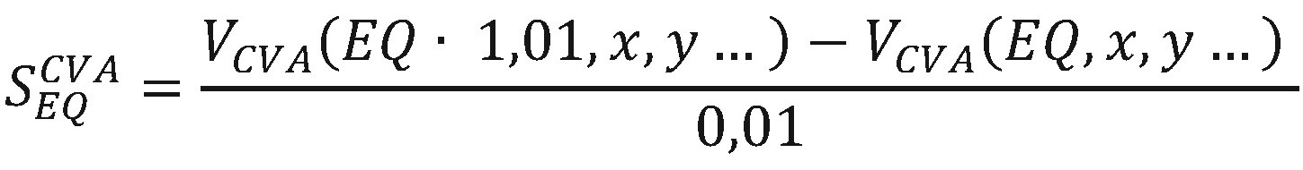

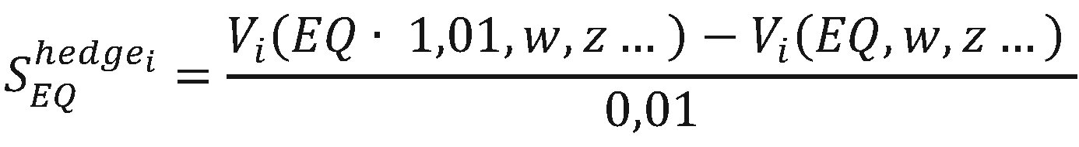
where:
= the sensitivities of the aggregate CVA to an equity spot price risk factor;
EQ = the value of the equity spot price;
V_{CVA}= the aggregate CVA calculated by the regulatory CVA model;
x, y = risk factors other than EQ in V_{CVA};
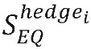= the sensitivities of the eligible hedge i to an equity spot price risk factor;
V _{i} = the pricing function of the eligible hedge i;
w, z = risk factors other than EQ in the pricing function V _{i} .

68. Banks shall calculate the delta sensitivities of the aggregate CVA to risk factors consisting of commodity spot prices, as well as of an eligible hedge instrument to those risk factors as follows:

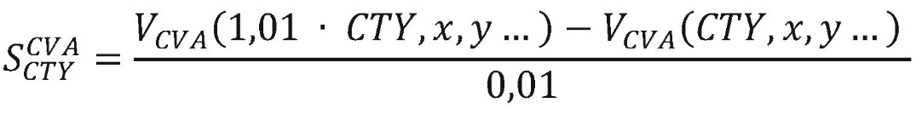

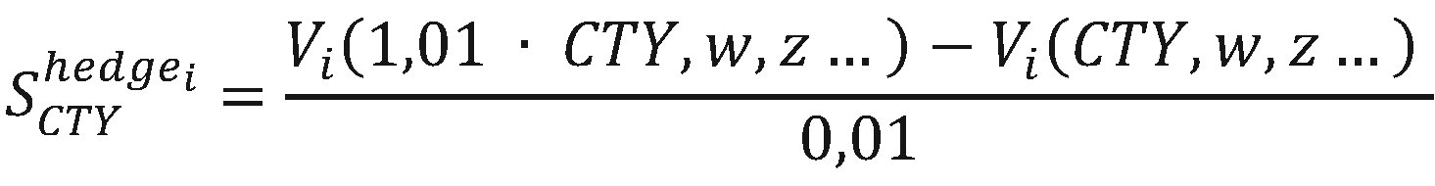
where:
= the sensitivities of the aggregate CVA to a commodity spot price risk factor;
CTY = the value of the commodity spot price;
V_{CVA} = the aggregate CVA calculated by the regulatory CVA model;
x, y = risk factors other than CTY in V _{CVA} ;
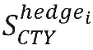= the sensitivities of the eligible hedge i to a commodity spot price risk factor;
V _{i =} the pricing function of the eligible hedge i;
w, z = risk factors other than CTY in the pricing function V _{i} .

69. Banks shall calculate the vega risk sensitivities of the aggregate CVA to risk factors consisting of implied volatility, as well as of an eligible hedge instrument to those risk factors, as follows:

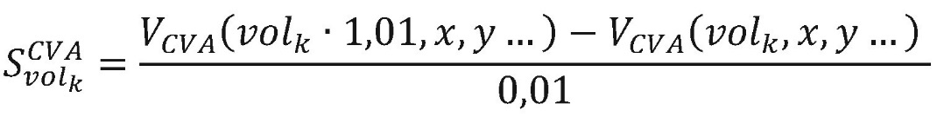

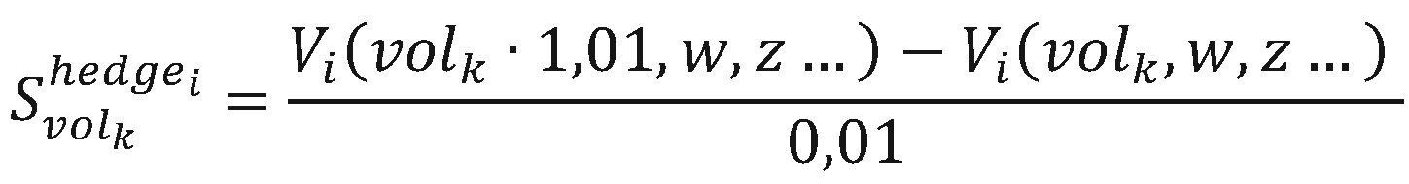
where:
= the sensitivities of the aggregate CVA to an implied volatility risk factor;
vol_{k} = the value of the implied volatility risk factor;
V_{CVA} = the aggregate CVA calculated by the regulatory CVA model;
x, y = risk factors other than vol_{k} in the pricing function V_{CVA} ;
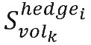= the sensitivities of the eligible hedge instrument i to an implied volatility risk factor;
V_{i} = the pricing function of the eligible hedge i;
w, z = risk factors other than vol_{k} in the pricing function Vi.

Section 11
Risk weights for interest rate risk
70. For the currencies referred to in paragraph 44, the risk weights of the risk-free rate delta sensitivities for each bucket in Table 1 shall be as follows:
Table 1

Bucket | Maturity | Risk weight
1 | 1 year | 1,11 %
2 | 2 years | 0,93 %
3 | 5 years | 0,74 %
4 | 10 years | 0,74 %
5 | 30 years | 0,74 %

71. For currencies other than the currencies referred to in paragraph 44, the risk weight of risk-free rate delta sensitivities shall be 1,58 %.
72. For inflation rate risk denominated in one of the currencies referred to in paragraph 44, the risk weight of delta sensitivity to the inflation rate risk shall be 1.11 %.
73. For inflation rate risk denominated in a currency other than those referred to in paragraph 44, the risk weight of the delta sensitivity to the inflation rate risk shall be 1,58 %.
74. The risk weights to be applied to sensitivities to interest rate vega risk factors and to inflation rate vega risk factors for all currencies shall be 100 %.

Section 12
Intra-bucket correlations for interest rate risk
and correlations across buckets for interest rate risk
75. For the currencies referred to in paragraph 44, the correlation parameters that banks shall apply to the aggregation of the risk-free rate delta sensitivities between the different buckets set out in paragraphs 70 to 74, Table 2, shall be the following:
Table 2

Bucket | 1 | 2 | 3 | 4 | 5
1 | 100 % | 91 % | 72 % | 55 % | 31 %
2 |  | 100 % | 87 % | 72 % | 45 %
3 |  |  | 100 % | 91 % | 68 %
4 |  |  |  | 100 % | 83 %
5 |  |  |  |  | 100 %

76. Banks shall apply a correlation parameter of 40 % for the aggregation of inflation rate delta risk sensitivity and risk-free rate delta sensitivity denominated in the same currency.
77. Banks shall apply a correlation parameter of 40 % for the aggregation of inflation rate vega risk factor sensitivity and interest rate vega risk factor sensitivity denominated in the same currency.
78. The cross-bucket correlation parameter for interest rate delta and vega risks shall be set at 0,5 % for all currency pairs.
Section 13
Risk weights for foreign exchange risk
79. The risk weights for all delta sensitivities to foreign exchange risk factor between a bank’s reporting currency and another currency shall be 11 %.
80. The risk weight of the foreign exchange risk factors concerning currency pairs which are composed of the euro and the currency of a Member State participating in ERM II shall be one of the following:
80.1. the risk weight referred to in paragraph 79, divided by 3;
80.2. the maximum permissible fluctuation within the official range agreed between the National Bank of Moldova and the central bank of the partner country, if this range is narrower than the standard range of 15 %.
81. By way of derogation from paragraph 80, the risk weight for foreign exchange risk factors in respect of currencies referred to in that paragraph that participate in ERM II with a formally agreed fluctuation band narrower than the standard range of plus or minus 15 % shall be equal to the maximum percentage fluctuation within that narrower band.
82. The risk weights for all vega sensitivities to foreign exchange risk factor shall be 100 %.
Section 14
Correlations for foreign exchange risk
83. A uniform correlation parameter of 60 % shall apply to the aggregation of sensitivities to delta foreign exchange risk factor across buckets.
84. A uniform correlation parameter of 60 % shall apply to the aggregation of the sensitivities to vega foreign exchange risk factor across buckets.
Section 15
Risk weights for counterparty credit spread risk
85. The risk weights for the delta sensitivities to counterparty credit spread risk factors shall be the same for all maturities (0,5 years, 1 year, 3 years, 5 years, 10 years) within each bucket in Table 3 and shall be the following:

Table 3

Bucket  number | Credit quality | Sector | Risk weight
1 | All | Central government authorities of the Republic of Moldova, National Bank of Moldova, including central government authorities of EU Member States, central banks | 0,5 %
2 | Credit quality step 1 to 3 | Authorities of the central government of the Republic of Moldova, including central banks, of third countries, multilateral development banks and international organisations referred to in the regulatory provisions for the treatment of market risk under the standardised approach. | 0,5 %
3 | Credit quality step 1 to 3 | Local public authority and public sector entities | 1,0 %
4 | Credit quality step 1 to 3 | Financial sector entities | 5,0 %
5 | Credit quality step 1 to 3 | Basic materials, energy, industrials, agriculture, manufacturing, mining and quarrying | 3,0 %
6 | Credit quality step 1 to 3 | Consumer goods and services, transportation and storage, administrative and support service activities | 3,0 %
7 | Credit quality step 1 to 3 | Technology, telecommunications | 2,0 %
8 | Credit quality step 1 to 3 | Health care, utilities, professional and technical activities | 1,5 %
9 | Credit quality step 1 to 3 | Covered bonds issued by banks established in EU Member States | 1,0 %
10 | Credit quality step 1 | Covered bonds issued by banks in third countries | 1,5 %
10 | Credit quality step 2-3 | Covered bonds issued by banks in third countries | 2,5 %
11 | Credit quality step 1 to 3 | Other sector | 5,0 %
12 | Credit quality step 1 to 3 | Qualified indices | 1,5 %
13 | Credit quality step 4 to 6 and unrated | Central government authorities of the Republic of Moldova, including central banks, of third countries, multilateral development banks and international organisations referred to in the market risk treatment regulations under the standardised approach. | 2,0 %
14 | Credit quality step 4 to 6 and unrated | Local public authority and public sector entities | 4,0 %
15 | Credit quality step 4 to 6 and unrated | Financial sector entities | 12,0 %
16 | Credit quality step 4 to 6 and unrated | Basic materials, energy, industrials, agriculture, manufacturing, mining and quarrying | 7,0 %
17 | Credit quality step 4 to 6 and unrated | Consumer goods and services, transportation and storage, administrative and support service activities | 8,5 %
18 | Credit quality step 4 to 6 and unrated | Technology, telecommunications | 5,5 %
19 | Credit quality step 4 to 6 and unrated | Health care, utilities, professional and technical activities | 5,0 %
20 | Credit quality step 4 to 6 and unrated | Other sector | 12,0 %
21 | Credit quality step 4 to 6 and unrated | Qualifying indices | 5,0 %

86. Where there are no external ratings for a specific counterparty, banks may, subject to prior approval by the National Bank of Moldova, map the internal rating to a corresponding external rating and assign a risk weight corresponding to either credit quality steps 1 to 3 or credit quality steps 4 to 6. Otherwise, the risk weights for unrated exposures shall be applied.
87. To assign a risk exposure to a sector, banks shall rely on a classification that is commonly used in the market for grouping issuers by sector. Banks shall assign each issuer to only one of the sector buckets set out in Table 3. Risk exposures from any issuer that the bank cannot assign to a sector in such a manner shall be assigned to either bucket 11 or bucket 20 of Table 3, depending on the credit quality of the issuer.
88. Banks shall assign to buckets 12 and 21 of Table 3 only exposures that reference qualified indices as referred to in paragraph 33.
89. Banks shall use a look-through approach to determine the sensitivities of an exposure referencing a non-qualified index.

Section 16
Intra-bucket correlations for counterparty credit spread risk
and correlations across buckets for counterparty credit spread risk
90. Between two sensitivities WS_{k} and WS_{l} , resulting from risk exposures assigned to sector buckets 1 to 11 and 13 to 20, as set out in paragraphs 85 and 86, the correlation parameter ρ_{kl} shall be set as follows:

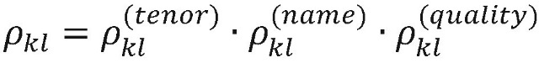
where:
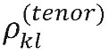 | shall be equal to 1 where the two sensitivities k and l are identical, otherwise it shall be equal to 90 %;
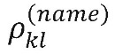 | shall be equal to 1 where the two names of sensitivities k and l are identical, 90 % if the two names are distinct but legally related, otherwise it shall be equal to 50 %;
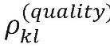 | shall be equal to 1 where the two names are both in buckets 1 to 11 or are both in buckets 13 to 20, otherwise it shall be equal to 80 %.

91. Between two sensitivities WS_{k} and WS_{l} resulting from risk exposures assigned to sector buckets 12 and 21, the correlation parameter ρ_{kl} is set as follows:

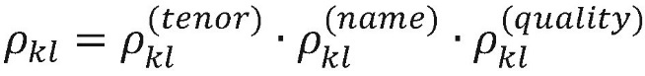
where:
shall be equal to 1 where the two vertices of the sensitivities k and l are identical, otherwise it shall be equal to 90 %;
shall be equal to 1 where the two names of sensitivities k and l are identical and the two indices are of the same series, 90 % if the two indices are the same but of distinct series, otherwise it shall be equal to 80 %;
shall be equal to 1 where the two names are both in bucket 12 or both in bucket 21, otherwise it shall be equal to 80 %.

92. The cross-bucket correlations for counterparty credit spread delta risk shall be the following:

Table 4

Bucket | 1, 2, 3, 13 and 14 | 4 and 15 | 5 and 16 | 6 and 17 | 7 and 18 | 8 and 19 | 9 and 10 | 11 and 20 | 12 and 21
1, 2, 3, 13 and 14 | 100 % | 10 % | 20 % | 25 % | 20 % | 15 % | 10 % | 0 % | 45 %
4 and 15 |  | 100 % | 5 % | 15 % | 20 % | 5 % | 20 % | 0 % | 45 %
5 and 16 |  |  | 100 % | 20 % | 25 % | 5 % | 5 % | 0 % | 45 %
6 and 17 |  |  |  | 100 % | 25 % | 5 % | 15 % | 0 % | 45 %
7 and 18 |  |  |  |  | 100 % | 5 % | 20 % | 0 % | 45 %
8 and 19 |  |  |  |  |  | 100 % | 5 % | 0 % | 45 %
9 and 10 |  |  |  |  |  |  | 100 % | 0 % | 45 %
11 and 20 |  |  |  |  |  |  |  | 100 % | 0 %
12 and 21 |  |  |  |  |  |  |  |  | 100 %

Section 17
Risk weights for reference credit spread risk
93. The risk weights for the delta sensitivities to reference credit spread risk factors shall be the same for all maturities (0,5 years, 1 year, 3 years, 5 years, 10 years) and all reference credit spread exposures within each bucket in Table 5 and shall be the following:

Table 5

Bucket  number | Credit quality | Sector | Risk weight
1 | All | Central government authorities of the Republic of Moldova, National Bank of Moldova, including central government authorities of EU Member States, central banks | 0,5 %
2 | Credit quality step 1 to 3 | Authorities of the central government of the Republic of Moldova, including central banks, of third countries, multilateral development banks and international organisations referred to in the regulatory provisions for the treatment of market risk under the standardised approach. | 0,5 %
3 | Credit quality step 1 to 3 | Local public authority and public sector entities | 1,0 %
4 | Credit quality step 1 to 3 | Financial sector entities | 5,0 %
5 | Credit quality step 1 to 3 | Basic materials, energy, industrials, agriculture, manufacturing, mining and quarrying | 3,0 %
6 | Credit quality step 1 to 3 | Consumer goods and services, transportation and storage, administrative and support service activities | 3,0 %
7 | Credit quality step 1 to 3 | Technology, telecommunications | 2,0 %
8 | Credit quality step 1 to 3 | Health care, utilities, professional and technical activities | 1,5 %
9 | Credit quality step 1 to 3 | Covered bonds issued by banks established in EU Member States | 1,0 %
10 | Credit quality step 1 | Covered bonds issued by banks in third countries | 1,5 %
10 | Credit quality step 2-3 | Covered bonds issued by banks in third countries | 2,5 %
11 | Credit quality step 1 to 3 | Qualifying indices | 1,5 %
12 | Credit quality step 4 to 6 and unrated | Authorities of the central government of the Republic of Moldova, including central banks, of third countries, multilateral development banks and international organisations referred to in the regulatory provisions for the treatment of market risk under the standardised approach | 2,0 %
13 | Credit quality step 4 to 6 and unrated | Local public authority and public sector entities | 4,0 %
14 | Credit quality step 4 to 6 and unrated | Financial sector entities | 12,0 %
15 | Credit quality step 4 to 6 and unrated | Basic materials, energy, industrials, agriculture, manufacturing, mining and quarrying | 7,0 %
16 | Credit quality step 4 to 6 and unrated | Consumer goods and services, transportation and storage, administrative and support service activities | 8,5 %
17 | Credit quality step 4 to 6 and unrated | Technology, telecommunications | 5,5 %
18 | Credit quality step 4 to 6 and unrated | Health care, utilities, professional and technical activities | 5,0 %
19 | Credit quality step 4 to 6 and unrated | Qualifying indices | 5,0 %
20 | Other sector |  | 12,0 %

94. Where there are no external ratings for a specific counterparty, banks may, subject to prior approval by the National Bank of Moldova, map the internal rating to a corresponding external rating and assign a risk weight corresponding to either credit quality steps 1 to 3 or credit quality steps 4 to 6. Otherwise, the risk weights for unrated exposures shall be applied.
95. Risk weights for reference credit spread volatilities shall be set at 100 %.
96. To assign a risk exposure to a sector, banks shall rely on a classification that is commonly used in the market for grouping issuers by sector. Banks shall assign each issuer to only one of the sector buckets in Table 5. Risk exposures from any issuer that the bank cannot assign to a sector in such a manner shall be assigned to bucket 20 of Table 5.
97. Banks shall assign to buckets 11 and 19 only exposures that reference qualified indices referred to in paragraph 33.
98. Banks shall use a look-through approach to determine the sensitivities of an exposure referencing a non-qualified index.
Section 18
Intra-bucket correlations for reference credit spread risk
99. Between two sensitivities WS_{k} and WS_{l} , resulting from risk exposures assigned to the sector buckets 1 to 10, 12 to 18 and 20 in paragraphs 93 and 94, the correlation parameter ρ_{kl} shall be set as follows:

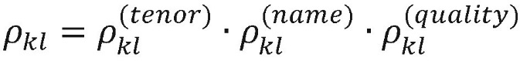
where:
shall be equal to 1 where the two vertices of the sensitivities k and l are identical, otherwise it shall be equal to 90 %;
shall be equal to 1 where the two names of sensitivities k and l are identical, 90 % where the two names are distinct but legally related, otherwise it shall be equal to 50 %;
shall be equal to 1 where the two names are both in buckets 1 to 10, are both in buckets 12 to 18 or are both in bucket 20, otherwise it shall be equal to 80 %.

100. Between two sensitivities WS_{k} and WS_{l}, resulting from risk exposures assigned to sector buckets 11 and 19, the correlation parameter ρ_{kl} shall be set as follows:

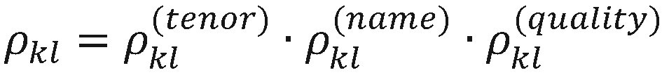
where:
shall be equal to 1 where the two vertices of the sensitivities k and l are identical, otherwise it shall be equal to 90 %;
shall be equal to 1 where the two names of sensitivities k and l are identical and the two indices are of the same series, 90 % if the two indices are the same but of distinct series, otherwise it shall be equal to 80 %;
shall be equal to 1 where the two names are both in bucket 11 or both in bucket 19, otherwise it shall be equal to 80 %.
Section 19
Correlations across buckets for reference credit spread risk
101. The cross-bucket correlations for reference credit spread delta risk and reference credit spread vega risk shall be the following:
Table 6

Bucket | 1, 2 and 12 | 3 and 14 | 4 and 15 | 5 and 16 | 6 and 17 | 7 and 18 | 8 and 19 | 9 and 10 | 20 | 11 | 19
1, 2 and 12 | 100 % | 75 % | 10 % | 20 % | 25 % | 20 % | 15 % | 10 % | 0 % | 45 % | 45 %
3 and 14 |  | 100 % | 5 % | 15 % | 20 % | 15 % | 10 % | 10 % | 0 % | 45 % | 45 %
4 and 15 |  |  | 100 % | 5 % | 15 % | 20 % | 5 % | 20 % | 0 % | 45 % | 45 %
5 and 16 |  |  |  | 100 % | 20 % | 25 % | 5 % | 5 % | 0 % | 45 % | 45 %
6 and 17 |  |  |  |  | 100 % | 25 % | 5 % | 15 % | 0 % | 45 % | 45 %
7 and 18 |  |  |  |  |  | 100 % | 5 % | 20 % | 0 % | 45 % | 45 %
8 and 19 |  |  |  |  |  |  | 100 % | 5 % | 0 % | 45 % | 45 %
9 and 10 |  |  |  |  |  |  |  | 100 % | 0 % | 45 % | 45 %
20 |  |  |  |  |  |  |  |  | 100 % | 0 % | 0 %
11 |  |  |  |  |  |  |  |  |  | 100 % | 75 %
19 |  |  |  |  |  |  |  |  |  |  | 100 %

102. By way of derogation from paragraph 101, the cross-bucket correlation values calculated in that paragraph shall be divided by 2 for correlations between a bucket from the group of buckets 1 to 10 and a bucket from the group of buckets 12 to 18.

Section 20
Risk weight buckets for equity risk
and correlations across buckets for equity risk
103. The risk weights for delta sensitivities to equity spot price risk factors shall be the same for all equity risk exposures in each bucket in Table 7 and shall be the following:
Table 7

Bucket  number | Market capitalisation | Economy | Sector | Risk weight for equity spot price
1 | Large | Emerging market economy | Consumer goods and services, transportation and storage, administrative and support service activities, healthcare, utilities | 55 %
2 | Large | Emerging market economy | Telecommunications, industrials | 60 %
3 | Large | Emerging market economy | Basic materials, energy, agriculture, manufacturing, mining and quarrying | 45 %
4 | Large | Emerging market economy | Financial sector entity as defined in Article 3 of Law No 202/2017 on the activity of banks, including government-backed financials, immovable property activities, technology | 55 %
5 | Large | Advanced economy | Consumer goods and services, transportation and storage, administrative and support service activities, healthcare, utilities | 30 %
6 | Large | Advanced economy | Telecommunications, industrials | 35 %
7 | Large | Advanced economy | Basic materials, energy, agriculture, manufacturing, mining and quarrying | 40 %
8 | Large | Advanced economy | Financial sector entity as defined in Article 3 of Law No 202/2017, including government-backed financials, immovable property activities, technology | 50 %
9 | Small | Emerging market economy | All sectors described under buckets 1, 2, 3 and 4 | 70 %
10 | Small | Advanced economy | All sectors described under buckets 5, 6, 7 and 8 | 50 %
11 | Other sector |  |  | 70 %
12 | Large | Advanced economy | Qualifying indices | 15 %
13 | Other |  | Qualifying indices | 25 %

104. The regulatory technical standards set out in the treatment of the market risk regulations according to the the standardised approach shall specify what constitutes a small capitalisation and what constitutes a large capitalisation for the purposes of paragraph 103.
105. The regulatory technical standards set out in the treatment of the market risk regulations according to the the standardised approach shall specify what constitutes an emerging market and what constitutes an advanced economy within the meaning of paragraph 103.
106. When assigning a risk exposure to a sector, banks shall rely on a classification that is commonly used in the market for grouping issuers by industry sector. Banks shall assign each issuer to one of the sector buckets in paragraph 103, Table 7, and shall assign all issuers from the same industry to the same sector. Risk exposures from any issuer that the bank cannot assign to a sector in that manner shall be assigned to bucket 11. Multinational or multi-sector equity issuers shall be allocated to a particular bucket on the basis of the most material region and sector in which the equity issuer operates.
107. The risk weights for equity vega risk shall be set at 78 % for buckets 1 to 8 and bucket 12 and at 100 % for all other buckets.
108. The cross-bucket correlation parameter for equity delta and vega risk shall be set at:
108.1. 15 % where the two buckets fall within buckets 1 to 10 of paragraph 103, Table 7;
108.2. 75 % where the two buckets are buckets 12 and 13 in paragraph 103, Table 7;
108.3. 45 % where one of the buckets is bucket 12 or 13 in paragraph 103, Table 7, and the other bucket falls within buckets 1 to 10 in paragraph 103, Table 7;
108.4. 0 % if one of the two buckets is bucket 11 in paragraph 103, Table 7.

Section 21
Risk weight buckets for commodity risk
109. The risk weights for the delta sensitivities to commodity spot price risk factors shall be the same for all commodity risk exposures within each bucket in Table 8 and shall be the following:

Table 8

Bucket number | Bucket name | Risk weight for  commodity spot prices
1 | Energy – solid combustibles | 30 %
2 | Energy – liquid combustibles | 35 %
3 | Energy – electricity | 60 %
4 | Energy – EU ETS carbon trading | 40 %
5 | Energy – non-EU ETS carbon trading | 60 %
6 | Freight | 80 %
7 | Metals – non-precious | 40 %
8 | Gaseous combustibles | 45 %
9 | Precious metals, including gold | 20 %
10 | Grains and oilseed | 35 %
11 | Livestock and dairy | 25 %
12 | Softs and other agricultural commodities | 35 %
13 | Other commodity | 50 %

110. The risk weights for commodity vega risk shall be set at 100 %.
Section 22
Correlations across buckets for commodity risk
111. The cross-bucket correlation parameter for commodity delta risk shall be set at:
111.1. 20 % where the two buckets fall within buckets 1 to 12 of paragraph 109, Table 8;
111.2. 0 % where one of the two buckets is bucket 13 of paragraph 109, Table 8.
112. The cross-bucket correlation parameter for commodity vega risk shall be set at:
112.1. 20 % where the two buckets fall within buckets 1 to 12 of paragraph 109, Table 8;
112.2. 0 % where one of the two buckets is bucket 13 in paragraph 109, Table 8.

CHAPTER V
BASIC APPROACH
113. The bank shall calculate the own funds requirements for CVA risk in accordance with paragraph 114 or 115, as applicable, for a portfolio of transactions with one or more counterparties, using one of the following formulae, as appropriate:
113.1. the formula set out in paragraph 114, where the bank includes in the calculation one or more eligible hedges recognised in accordance with paragraphs 119 to 124;
113.2. the formula set out in paragraph 115, where the bank does not include in the calculation any eligible hedges recognised in accordance with paragraphs 119 to 124.
The approach set out in paragraph 113.1 shall not be used in combination with the approach set out in paragraph 113.2.
114. The bank that meets the condition referred to in paragraph 113.1 shall calculate the own funds requirements for CVA risk as follows:

BACVA^{total} = β · BACVA^{csr–unhedged} + DS_{CVA} · (1 – β) · BACVA^{csr–hedged}
where:
BACVA^{total} | = the own funds requirements for CVA risk under the basic approach;
BACVA^{csr–unhedged} | = the own funds requirements for CVA risk under the basic approach as calculated in accordance with paragraph 115 for the bank that meets the condition set out in subparagraph 113.2;
DS _{CVA} | = 0,65;
β | = 0,25;

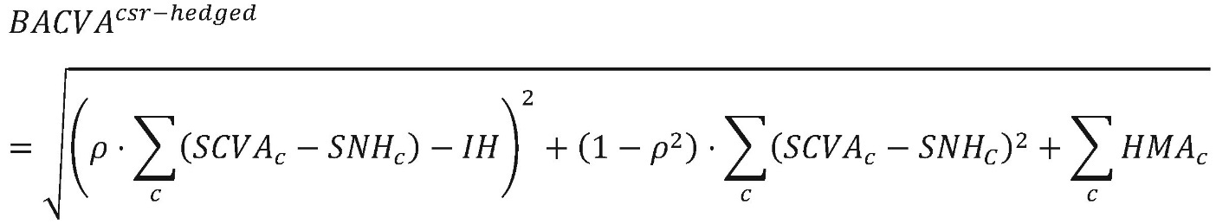
where:
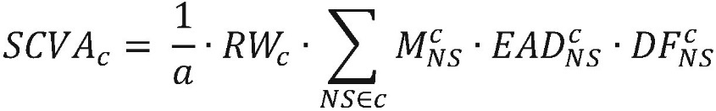
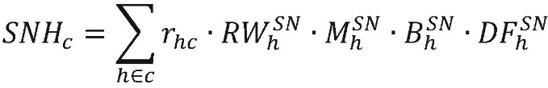
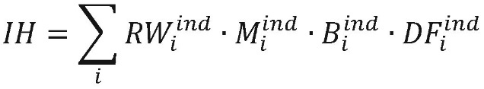
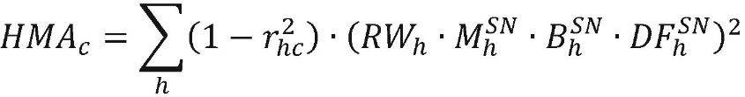
a = 1,4;
p = 0,5;
C = the index that denotes all counterparties for which the bank calculates the own funds requirements for CVA risk using the basic approach;
NS = the index that denotes all netting sets with a given counterparty for which the bank calculates the own funds requirements for CVA risk using the basic approach;
H = the index that denotes all single-name instruments recognised as eligible hedges in accordance with paragraphs 119–124 for a given counterparty for which the bank calculates the own funds requirements for CVA risk using the basic approach;
I = the index that denotes all index instruments recognised as eligible hedges in accordance with paragraphs 119–124 for all counterparties for which the bank calculates the own funds requirements for CVA risk using the basic approach;
RW_{c} = the risk weight applicable to counterparty c; counterparty c is mapped to one of the risk weights based on a combination of sector and credit quality and determined in accordance with Table 9.

Where there are no external ratings for a specific counterparty, banks may, subject to the approval of the National Bank of Moldova, map the internal rating with a corresponding external rating and assign a risk weight corresponding to either credit quality step 1 to 3 or credit quality step 4 to 6; otherwise, risk weights for unrated exposures shall be applied.
M ^{c}_{NC} = effective maturity of the netting set NS with counterparty c;
M ^{c}_{NS} = shall be calculated in accordance with the internal rating based approach; however, for that calculation, M ^{c}_{NS} shall not be capped at five years, but at the longest contractual remaining maturity in the netting set;
EAD ^{c}_{NS} = the the counterparty credit risk exposure value of the netting set NS with counterparty c, including the effect of collateral in accordance with the methods laid down in the Regulation on the treatment of counterparty credit risk for banks, approved by the Decision of the Executive Board of the National Bank of Moldova No 220/2025 (hereinafter – Regulation No 220/2025 on the treatment of counterparty credit risk for banks) as applicable for the calculation of own funds requirements for counterparty credit risk referred to in the regulatory provisions on banks’ own funds and capital requirements;
DF ^{c}_{NS} = supervisory discount factor for the netting set NS with counterparty c.
For a bank using the internal model method set out in Regulation No 220/2025 on the treatment of counterparty credit risk for banks, the discount factor required by supervisory authorities shall be set at 1; otherwise, the supervisory discount factor shall be calculated as follows:

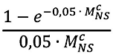
r_{hc} = the supervisory correlation factor determined in accordance with Table 10 between credit spread risk of counterparty c and the credit spread risk of a single-name instrument recognised as an eligible hedge h for counterparty c;
M _{h}^{SN} = the residual maturity of a single-name instrument recognised as an eligible hedge;
B _{h}^{SN} = the notional of a single-name instrument recognised as an eligible hedge;
DF _{h}^{SN} = the supervisory discount factor for a single-name instrument recognised as an eligible hedge, calculated as follows:

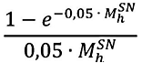
RW _{h}^{SN} = the supervisory risk weight of a single-name instrument recognised as an eligible hedge; those risk weights shall be based on a combination of sector and credit quality of the reference credit spread of the hedging instrument and are determined in accordance with Table 9;
M _{i}^{ind} = the residual maturity of one or more positions in the same index instrument recognised as an eligible hedge; where there is more than one position in the same index instrument, M _{i} ^{ind} shall be the notional-weighted maturity of all those positions;
B _{i}^{ind} = the full notional of one or more positions in the same index instrument recognised as an eligible hedge;
DF _{i}^{ind} = the supervisory discount factor for one or more positions in the same index instrument recognised as an eligible hedge, calculated as follows:
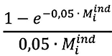
RW _{i}^{ind} = the supervisory risk weight of an index instrument recognised as an eligible hedge; RW _{i}^{ind} shall be based on a combination of sector and credit quality of all index constituent, calculated as follows:
i) where all index constituents belong to the same sector and have the same credit quality, as determined in accordance with Table 9, shall be calculated as the relevant risk weight in Table 9 for that sector and that credit quality multiplied by 0,7;
ii) where all index constituents do not belong to the same sector or do not have the same credit quality, RW_{i}^{ind} shall be calculated as the weighted average of the risk weights of all index constituents, as determined in accordance with Table 9 multiplied by 0,7;

Table 9

Sector of counterparty | Credit quality
Sector of counterparty | Credit quality  step 1 to 3 | Credit quality step 4 to 6 and not rated
Authorities of the central government of the Republic of Moldova, including central banks, multilateral development banks and international organisations referred to in the provisions of the regulations on the treatment of the market risk according to the standardised approach | 0,5 % | 2,0 %
Local public authority and public sector entities | 1,0 % | 4,0 %
Financial sector entities | 5,0 % | 12,0 %
Basic materials, energy, industrials, agriculture, manufacturing, mining and quarrying | 3,0 % | 7,0 %
Consumer goods and services, transportation and storage, administrative and support service activities | 3,0 % | 8,5 %
Technology, telecommunications | 2,0 % | 5,5 %
Health care, utilities, professional and technical activities | 1,5 % | 5,0 %
Other sector | 5,0 % | 12,0 %

Table 10

Correlations between credit spread of counterparty and single-name hedge
Single-name hedge h of counterparty i | Value of r_{hc}
Counterparties referred to in subparagraph 122.1.1. | 100 %
Counterparties referred to in subparagraph 122.1.2. | 80 %
Counterparties referred to in subparagraph 122.1.3. | 50 %

115. The bank that meets the condition referred to in subparagraph 113.2. shall calculate the own funds requirements for CVA risk as follows:
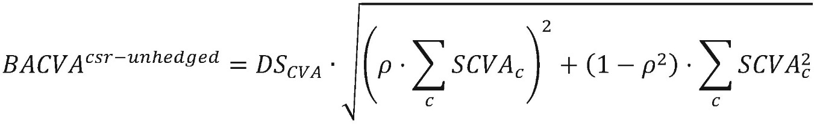
where all the terms are as set out in paragraph 114.

CHAPTER VI
SIMPLIFIED APPROACH
116. A bank which, in accordance with Regulation No 220/2025 on the treatment of counterparty credit risk for banks, fulfils all the conditions for the use of simplified methods for calculating the exposure value or to which the National Bank of Moldova has allowed it to apply the approach set out in the initial exposure method, may calculate the own funds requirements for CVA risk as the risk-weighted exposure amounts for counterparty risk for non-trading book and trading book positions, respectively, specified in the provisions of the regulations for banks’ own funds and capital requirements, divided by 10.
117. For the purposes of the calculation referred to in paragraph 116, the following requirements shall apply:
117.1. only transactions subject to the own funds requirements for CVA risk set out in paragraphs 4 to 10 shall be subject to this calculation;
117.2. credit derivatives that are recognised as internal hedges against counterparty risk exposures shall not be included in this calculation.
118. A bank that no longer meets one or more of the conditions for the use of simplified methods for calculating the exposure value shall comply with the provisions for non-compliance with the conditions for the use of simplified methods for calculating the exposure value for derivatives laid down in Regulation No 220/2025 on the treatment of counterparty credit risk for banks.

CHAPTER VII
ELIGIBLE HEDGES
119. Positions in hedging instruments shall be recognised as “eligible hedges” for the calculation of the own funds requirements for CVA risk in accordance with paragraphs 17–20 and 113–115 where those positions meet all of the following requirements:
119.1. they are used to mitigate CVA risk and are managed as such;
119.2. they can be opened into with third parties or with the bank's trading book as an internal hedge, in which case they are to comply with the provisions referred to in the regulation on the treatment of the market risk according to the standardised approach;
119.3. only positions in hedging instruments as referred to in paragraphs 121 and 122 can be recognised as eligible hedges for the calculation of the own funds requirements for CVA risk in accordance with paragraphs 17-20 and 113-115.
120. For the purposes of calculating the own funds requirements for CVA risk in accordance with paragraphs 17–20, positions in hedging instruments shall be recognised as eligible hedges where, in addition to the conditions set out in subparagraphs 119.1–119.3, those hedging instruments form a single position in an eligible hedge and are not split into more than one position in more than one eligible hedge.
121. For the calculation of own funds requirements for CVA risk in accordance with paragraphs 17–20, only positions in the following hedging instruments shall be recognised as eligible hedges:
121.1. instruments that hedge variability of the counterparty credit sprea, with the exception of instruments referred to in the regulation on the treatment of the market risk according to the standardised approach;
121.2. instruments that hedge variability of the exposure component of CVA risk, with the exception of the instruments referred to in the regulation on the treatment of the market risk according to the standardised approach.
122. For the calculation of the own funds requirements for CVA risk in accordance with paragraphs 113–115 only positions in the following hedging instruments shall be recognised as eligible hedges:
122.1. single-name credit default swaps and single-name contingent-credit default swaps referencing:
122.1.1. the counterparty directly;
122.1.2. an entity legally related to the counterparty, where “legally related” refers to cases where the reference name and the counterparty are either a parent undertaking and its subsidiary or two subsidiaries of a common parent;
122.1.3. an entity belonging to the same sector and region as the counterparty;
122.2. index credit default swaps.
123. Positions in hedging instruments entered into with third parties that are recognised as eligible hedges in accordance with paragraphs 119-122 and included in the calculation of the own funds requirements for CVA risk shall not be subject to the own funds requirements for market risk set out in the regulation on the treatment of the market risk according to the standardised approach.
124. Positions in hedging instruments that are not recognised as eligible hedges in accordance with paragraphs 119-123 shall be subject to the own funds requirements for market risk set out in the normative acts on the treatment of the market risk according to the standardised approach.

CHAPTER VIII
GRANTING OF PRIOR APPROVAL
125. This Chapter shall apply to prior approvals issued by the National Bank of Moldova in accordance with paragraphs 11, 15, 17 and 26. In order to issue prior approval, the bank shall submit to the National Bank of Moldova an application accompanied by the documents and information set out in the Annex to this Regulation, which shall substantiate the request/confirm whether the requirements set out in those paragraphs are met.
126. The application, as well as the documents and information referred to in paragraph 125, shall be submitted to the National Bank of Moldova in the Romanian language and shall be signed by the person authorised by the bank.
127. If the documents and/or information specified in paragraph 125 do not correspond to paragraphs 125 and 126, the National Bank of Moldova shall notify the bank in writing within 5 working days of the date of submission of the application. The bank shall, within 10 working days from the date of receipt of the letter of the National Bank of Moldova, complete and submit to the National Bank of Moldova the missing documents and/or information.
128. If the bank fails to complete the set of documents and information within the deadline specified in paragraph 127, the National Bank of Moldova shall notify the bank of the termination of the administrative procedure within 3 working days of the expiry of the deadline.
129. Within 60 working days from the date of receipt of the complete set of documents and information in accordance with this Chapter, the National Bank of Moldova shall issue the appropriate prior approval or reject the application, notifying the bank of its decision. If further examination is required or more time is needed to process the information and documents, the deadline may be extended by a maximum of 30 working days, upon notification to the bank.
130. If the documents and information submitted in accordance with this Chapter are insufficient to take a decision on the request for prior approval in the context of paragraph 125, the National Bank of Moldova shall have the right to require the submission of additional documents and information.
131. The Bank shall be obliged to submit the additional information and documents within the period specified by the National Bank of Moldova, during which the period referred to in paragraph 129 shall be suspended.
132. If the application for prior approval is rejected, the grounds on which the application is rejected shall be indicated. The grounds for rejecting the application for prior approval of the National Bank of Moldova shall be the following:
132.1. failure to meet the requirements set for obtaining such prior approval, as appropriate, and/or
132.2. submission to the National Bank of Moldova of erroneous, inauthentic and/or contradictory information;
132.3. failure to submit documents and information confirming that the bank has met the requirements set for obtaining such prior approval.
133. The Bank has the right to apply the provisions set out in the prior approval starting with the date of issuance of the prior approval.

Annex
the Treatment Regulation
credit valuation adjustment risk for banks

List of documents
to be attached to the request for prior approval
of the use of the standardised or basic approach
1. A document, signed by a person authorised to represent the bank, which:
1.1. describes the process of applying the standardised or basic approach, set out its conclusions, confirming the bank's compliance with the specific requirements for applying the standardised or basic approach;
1.2. communicates the structure of the group to which the bank belongs, the competent authorities responsible for supervising its members and the standardised or basic approach used by it – in the cases specified in paragraphs 11, 15, 17, 26 and 114 of the Regulation on the treatment of credit valuation adjustment risk for banks.
2. The internal audit report assessing the adequacy of the credit valuation adjustment risk management system and of the application process of the standardised or basic approach will follow the compliance with the requirements specified in the Regulation on the treatment of credit valuation adjustment risk for banks.
3. Form C 25.01 on credit valuation adjustment risk (CVA) set out in the Instruction on submission by banks of COREP reports for supervisory purposes, approved by Decision No 117/2018 of the National Bank, accompanied by the method for determining relevant indicators for business lines.

